2021 SUMMER PROGRAMS • DANCE CAMPS AGES 3-6

STUDENT INFORMATION:
Name
Address
City State_____________ Zip
Phone # Date of Birth Age

IN CASE OF EMERGENCY CONTACT:
Name
Phone # Cell # ______
Parent email:

Attending Camp with a friend? Please list their name(s)

Selection(s) | Ages 3-6
 | June 21-25 | Elsa & Anna’s Summer Summer Adventures  Embark upon an adventure with Elsa and Anna complete with themed crafts, activities and dances!  9:00 AM – 12:00 PM
 | June 28-July 2 | Royal princess ball  Dancers will enjoy ‘Frozen’ & ‘Frozen Fever’ themed crafts, activities and dances fit for an ice princess!  9:00 AM – 12:00 PM
 | July 12-16 | moana’s island party  Based on the movie ‘Moana’, dancers will enjoy tropical themed crafts & dances based on the importance of leadership & finding yourself.  9:00 AM – 12:00 PM
 | July 19-23 | Frozen princess celebration  Dancers will enjoy ‘Frozen’ and ‘Frozen Fever’ themed crafts, activities and dances fit for an ice princess! Dancers will twirl and leap like real ballerinas in this camp complete with crafts, activities and dances!  9:00 AM – 12:00 PM
 | July 26-30 | fairytale princesses  Dancers will feel like real princesses as we explore the stories of the Disney princesses through crafts, activities and dances!  9:00 AM – 12:00 PM

MEDICAL & RISK WAIVER
I hereby give my permission for my child to participate in the activities of the Summer Dance Camp. I release Central Indiana Academy of Dance, its Officers and Employees from any responsibility for any accident or injury that could occur. I have alerted the staff of any problems or medical restrictions that my child has.

ANY CONCERNS?

GUARDIAN’S SIGNATURE
DATE

CONSENT
I understand and allow; that any photo and video materials with my child’s participation to be free for further use by Central Indiana Academy of Dance. I acknowledge my child is potty-trained.
GUARDIAN’S SIGNATURE
DATE

PAYMENT IS DUE AT TIME OF REGISTRATION, SPACE IS LIMITED
ALL FEES ARE NON-REFUNDABLE

Educating Inspiring Performing

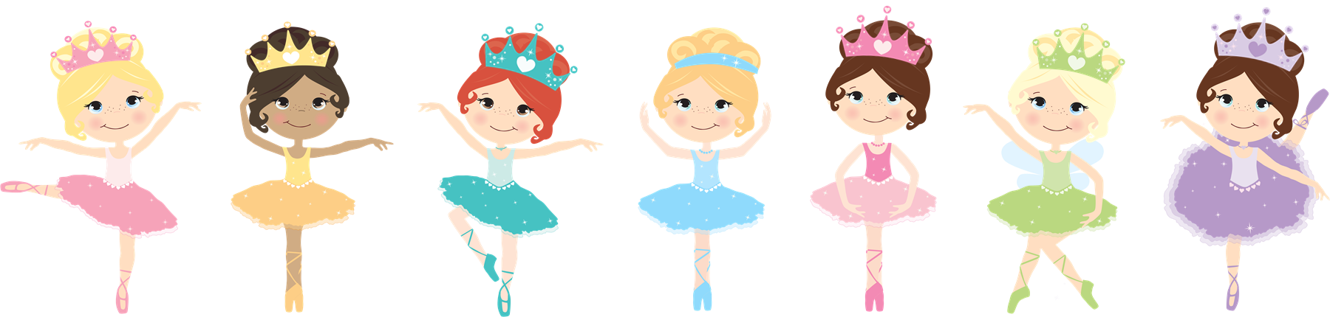

2021 Summer Dance Camps
for ages 3-6*

All camps are Monday thru Friday from 9:00 am to 12:00 pm.

$140 for the week

Space is limited
ALL FEES ARE NON-REFUNDABLE

June 21-25 | Elsa & Anna’s Summer Adventures
June 28-July 2 | Royal princess ball
July 12-16 | Moana’s Island Party
July 19-23 | Frozen Princess celebration
July 26-30 | Fairytale Princesses

Enroll the same child in more than one camp and receive an additional 5% discount with code
*All attending must be potty-trained

